Week 1 Activity 1

Matt Sievers

Grand Canyon University: CST-236

11.03.2020

GIT Repo:

Screen shot 1

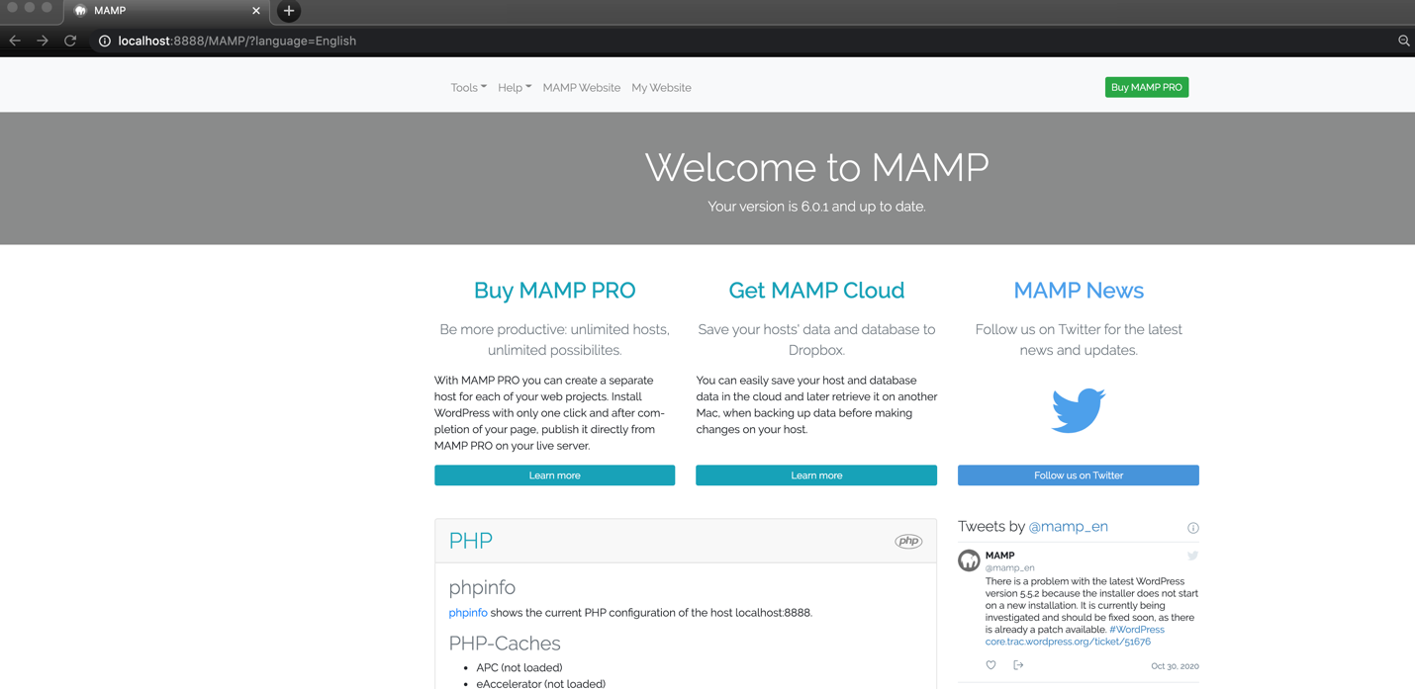

Screen Shot 2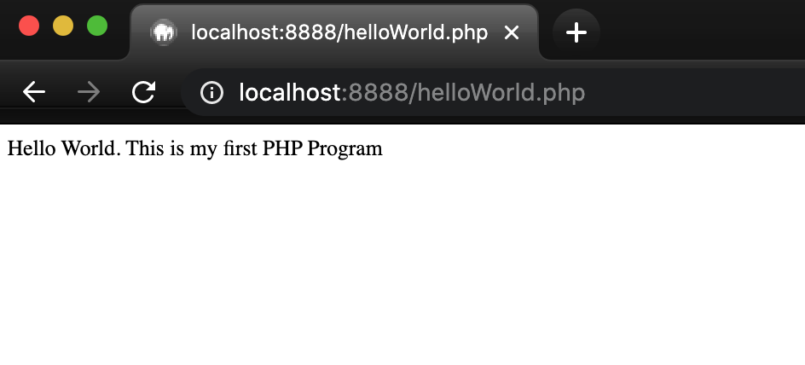

Screen shot 3

Screen shot 4

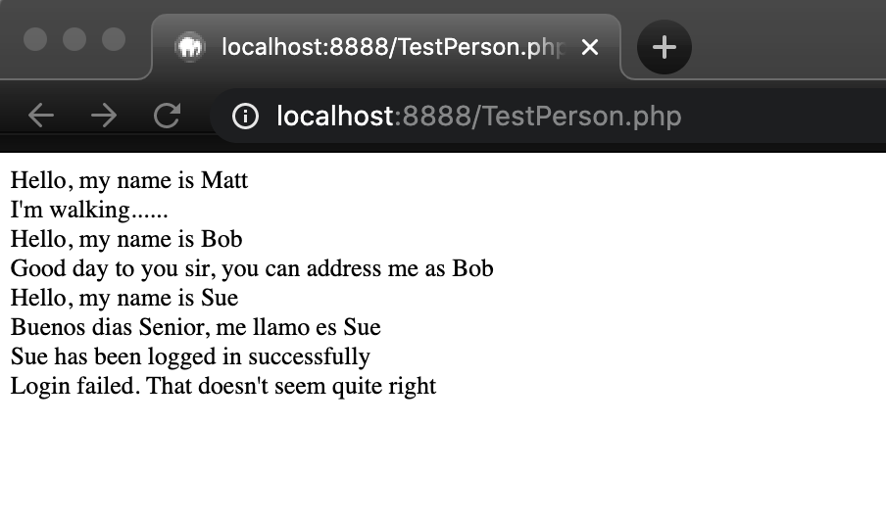

Screen Shot 5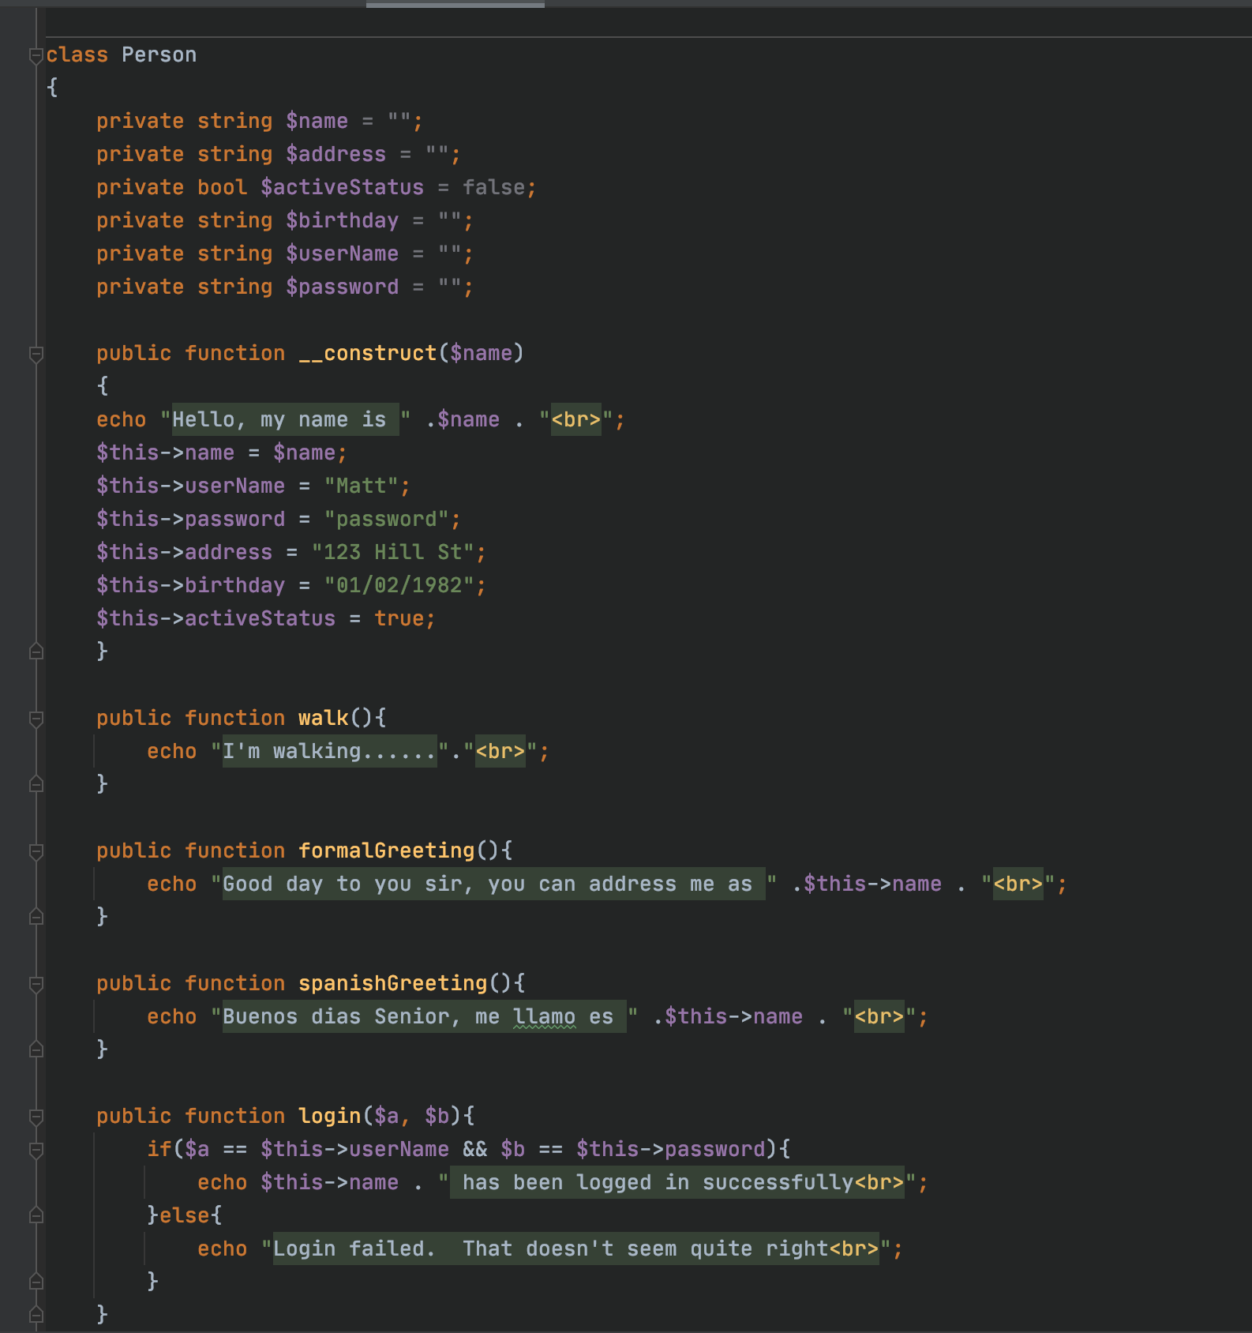

Screen shot 6 RaceCar UML

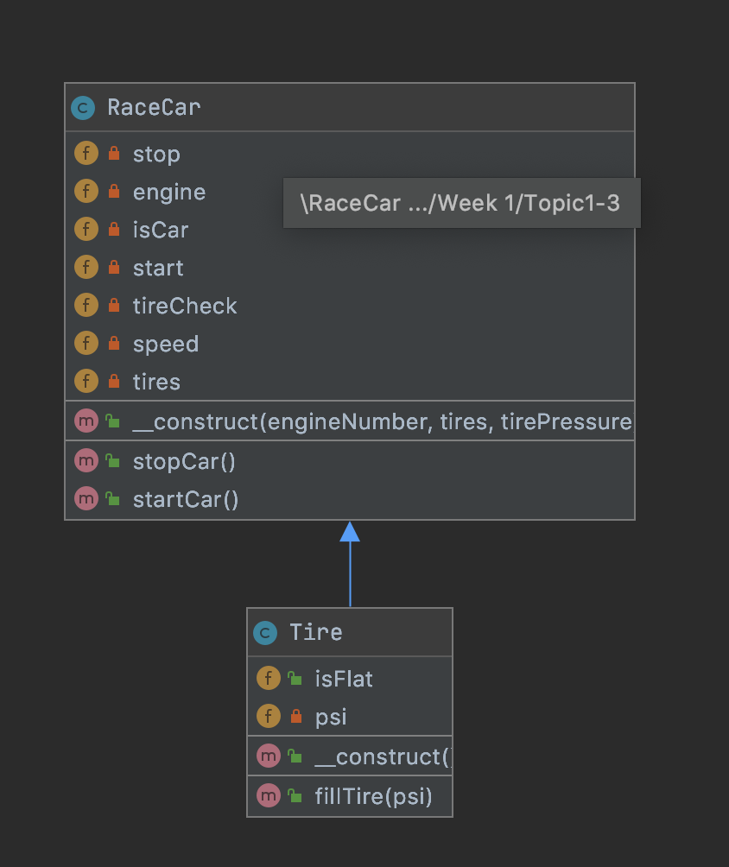

Screen shot 7 RaceCar in action

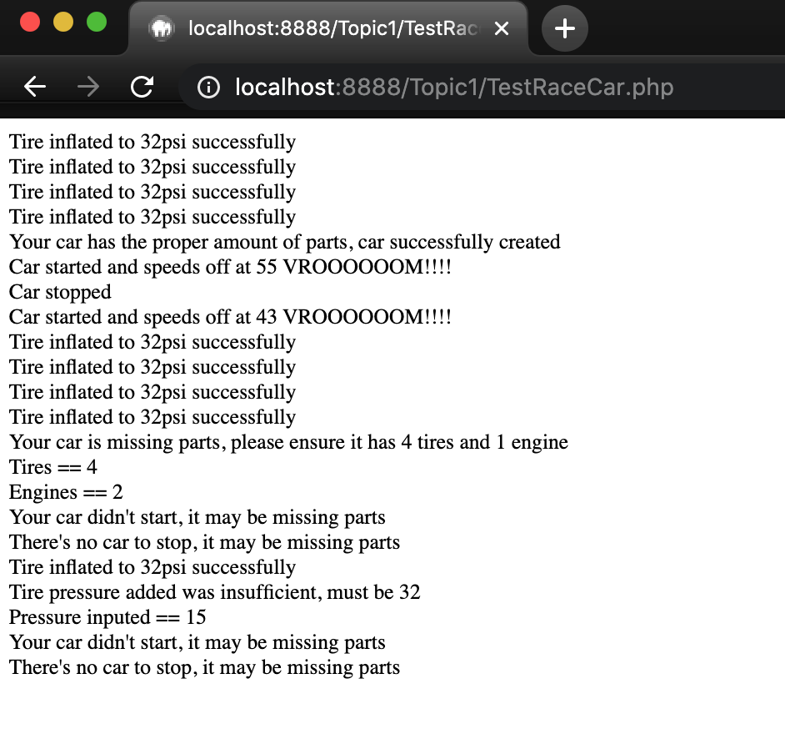

Screen shot 8 Superhero PlayGame.php

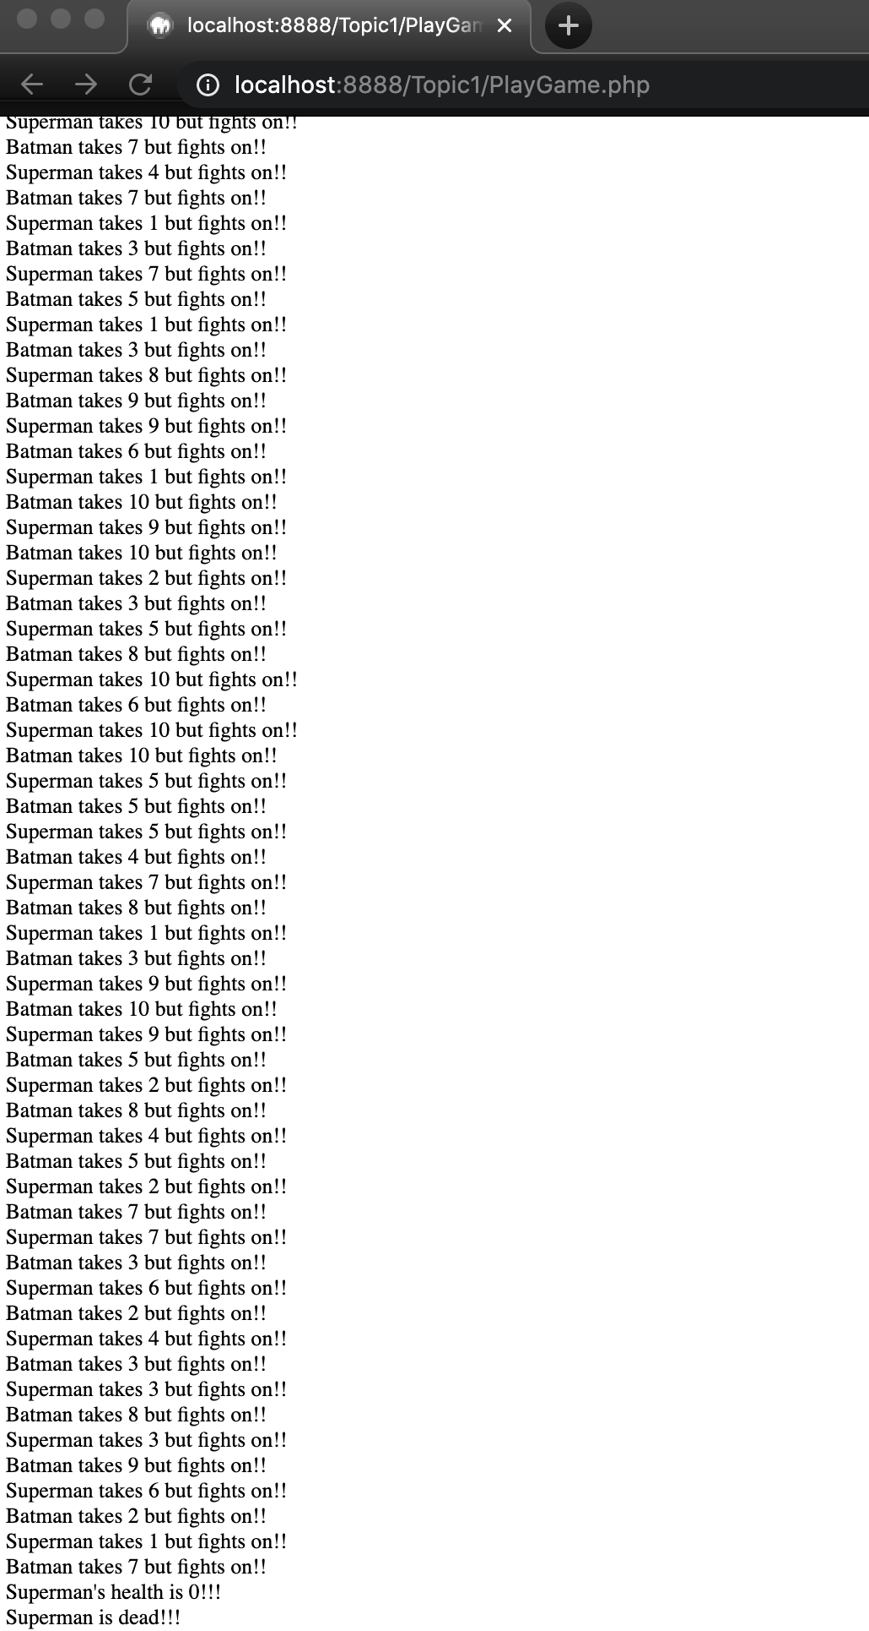

Screen shot 9 Static Variable

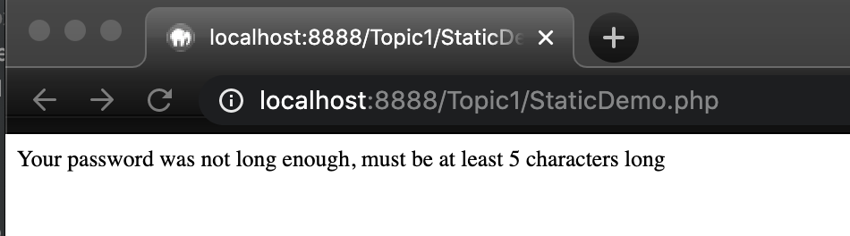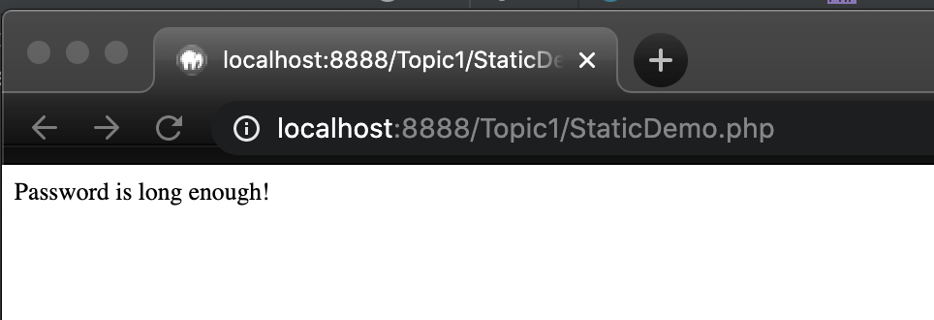

Screen Shot 10 Abstract AnimalsDemo

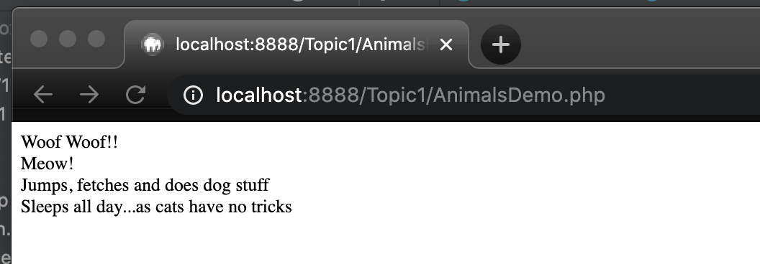

Screen Shot 11 Final pre Final keyword added to getOlderBy()

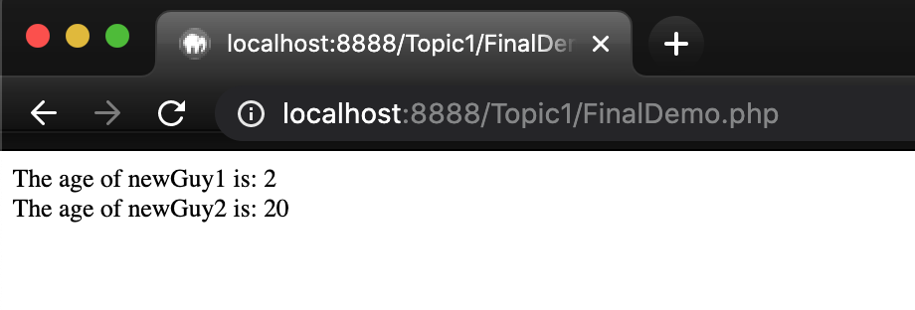

Screen Shot 12 Final post Final Keyword on getOlderBy() (throws error)

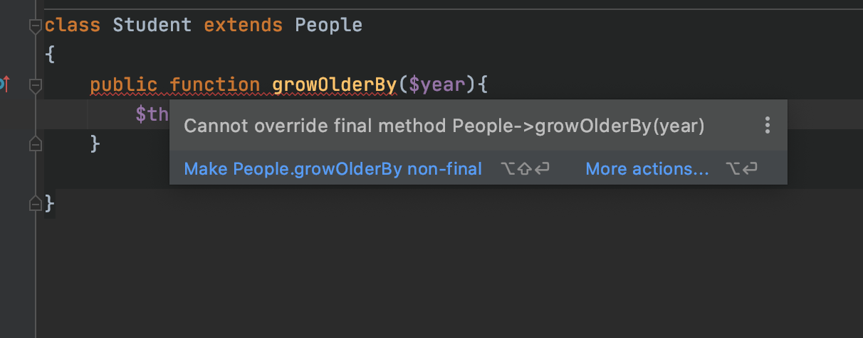

References

ASP.NET MVC (n.d.). *Overview. Retrieved from:* <https://www.tutorialspoint.com/asp.net_mvc/asp.net_mvc_overview.htm>.

ASP.NET MVC (n.d.). *Life Cycle. Retrieved from:* <https://www.tutorialspoint.com/asp.net_mvc/asp.net_mvc_life_cycle.htm>

ASP.NET MVC (n.d.). *Routing. Retrieved from:* <https://www.tutorialspoint.com/asp.net_mvc/asp.net_mvc_routing.htm>

ASP.NET MVC (n.d.). *Controllers. Retrieved from:* <https://www.tutorialspoint.com/asp.net_mvc/asp.net_mvc_controllers.htm>

ASP.NET MVC (n.d.). *Selectors. Retrieved from:* <https://www.tutorialspoint.com/asp.net_mvc/asp.net_mvc_selectors.htm>

ASP.NET MVC (n.d.). *Data Model. Retrieved from:* <https://www.tutorialspoint.com/asp.net_mvc/asp.net_mvc_data_model.htm>

Microsoft Docs (n.d.). *SqlConnection Class. Retrieved from:*

<https://docs.microsoft.com/en-us/dotnet/api/system.data.sqlclient.sqlconnection?view=dotnet-plat-ext-3.1>

Microsoft Docs (n.d.). *Retrieve data using a DataReader. Retrieved from:*

https://docs.microsoft.com/en-us/dotnet/framework/data/adonet/retrieving-data-using-a-datareader